

**Bio’s and session descriptions**

**Part 1: Keynote:**

**Advancing gender equity in STEMM: Lessons from the Smart Wife: Yolande Strengers**

**Yolande**  is an Associate Professor of Digital Society and Technology in the Emerging Technologies Research Lab, and Associate Dean of Equity, Diversity and Inclusion in the Faculty of Information Technology at Monash University, Melbourne, Australia. She is co-author of The Smart Wife: Why Siri, Alexa and Other Smart Home Devices Need a Feminist Reboot with Jenny Kennedy (The MIT Press, 2020*).*

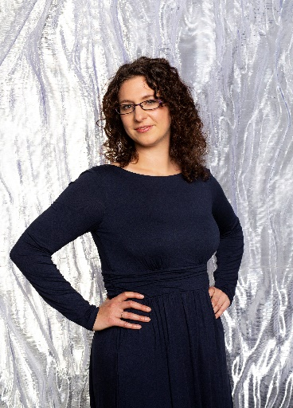This talk will introduce you to the 'smart wife' – smart home technologies that are taking on traditionally feminised wifely roles in the home. Originating from male-dominated computing science disciplines, the smart wife is an exemplar of how advanced technology can reverse the progress made so far towards gender equity. Yolande will outline several proposals to address the systemic inequities now seen in many technical disciplines and the problems these can create.    
----------------------------------------------------------------------------------------------------------------------

**Part 2: Parallel Discussions  
  
Inclusive connections: Bonnie Beerkens  
Bonnie** is Program Coordinator Research & Valorization and Program Coordinator PROOF (HRM, Professional Development)

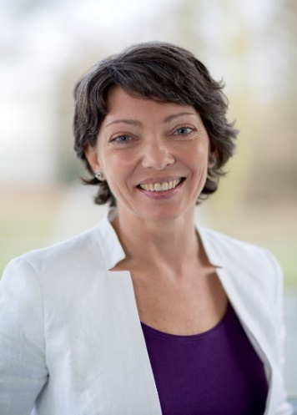

**Description of the session**: We will discuss how WISE members/participants can learn to develop professional skills to connect and build inclusive networks within the TU/e community as well as the wider scientific community.   
-----------------------------------------------------------------------------------------------------------   
**Connecting with WISE Community: Marion Matters  
Marion** is a Full Professor in Terahertz Integrated Circuit design. She is Vice-Dean and Graduate Program Director at the faculty of Electrical Engineering, Eindhoven University of Technology and Chair of the WISE-Network. In 2019, she co-founded TeraNova, a start-up company that develops high resolution THz microscopes.

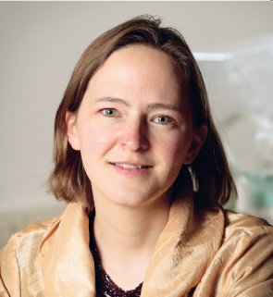

**Description of the session**: Together we will explore what the WISE-Network could provide for you and what you could bring to the network. Maybe you have an idea for a new activity, or you have encountered issues that can be resolved with the support of WISE? Eventually you see connections between WISE and other organizations.   
You are very welcome to join this session and connect with WISE!

**-**-----------------------------------------------------------------------------------------------------------

**Connecting with industry: Monique Bruining  
Monique** is Managing Director ICMS (TU/e). After obtaining her PhD degree, she embarked on a journey in industry. Monique worked at Johnson & Johnson and DPI (operating in between industry and academia). She is now happy to use the knowledge and expertise that she gained over the years at ICMS.

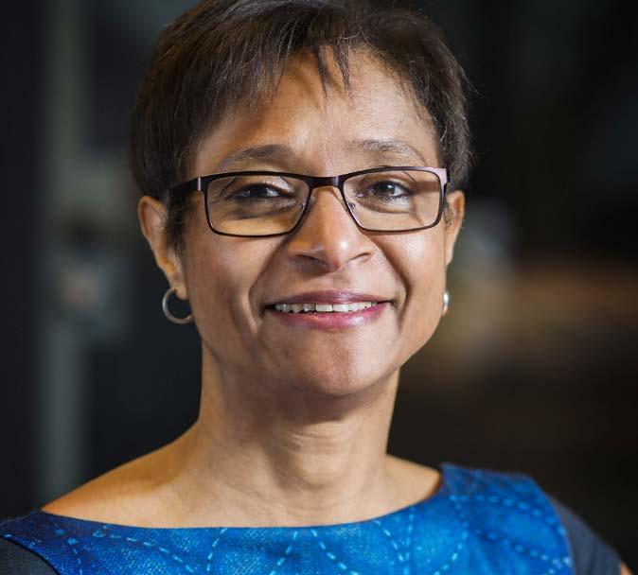

**Description of the session**: Connecting-with-industry can mean a number of things:

* you want to find a job in industry
* you want to start a research project or another type of collaboration with industry
* you are a member of a student team that is sponsored by industry
* etc…

During this session we will touch upon important aspects when connecting academia and industry.

----------------------------------------------------------------------------------------------------------------

**Connecting with the regional innovation ecosystem: Isabelle Reymen   
Isabelle** is a Full Professor of Design of Innovation Ecosystems, in the Innovation,

Technology Entrepreneurship and Marketing (ITEM) group of the department of Industrial Engineering & Innovation Sciences, and ScientificDirector of TU/e innovation Space.

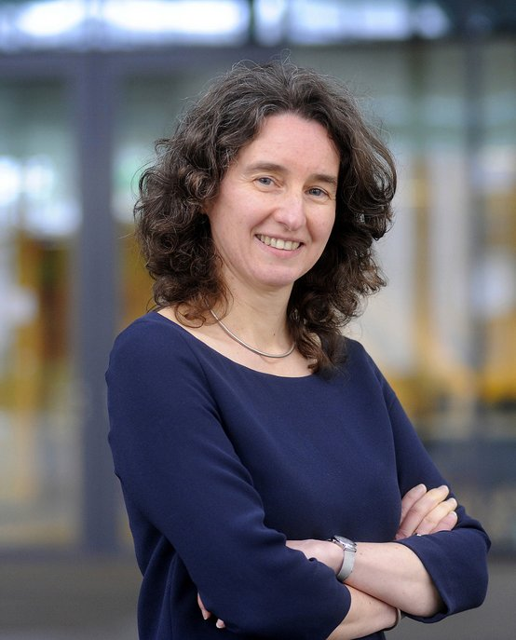

**Description of the session:** This session focuses on how to collaborate within the regional innovation ecosystem to create social and economic impact. Universities can take an entrepreneurial role as partner in collaborations with the private sector, the government and the general public, implying a new reality for students as well as university staff.

----------------------------------------------------------------------------------------------------------------

**Connecting through networking: Daniel Tetteroo  
Daniel** is an Assistant Professor at the department of Industrial Design. His interests are, amongst others, in designing for rehabilitation & healthy living, end-user adaptable systems, playful interaction and communities.  
  
  
  
**Description of the session:** Most societal challenges require a multi**-**disciplinary approach. But how to meet researchers from entirely different disciplines and in different institutes? How does this help in shaping unusual collaborations? And how to make such collaborations successful? Let’s collaborate to find out!