

The emission and absorption of light is the

physical basis of lasers, LEDs, solar cells and

photodetectors, which have become crucial

parts of our daily life. By controlling these

processes at a subwavelength scale, we can

significantly improve the performance of these

photonic devices and develop completely new

ones. The Photonics and Semiconductor

Nanophysics group investigates the physics of

(

nano-)photonic structures and materials in five

distinct but related research lines, mostly

centered around semiconductors, for

applications ranging from optical

communications to sensing and energy

conversion.

Photonics and

Semiconductor

Nanophysics

Bachelor and Master Research

Projects (2022-2023)

Andrea Fiore, Jaime Gómez Rivas,

Paul

Koenraad

,

Andrei

Silov

, Ewold Verhagen

**Information on available Bachelor / Master projects in the PSN group**

(applies to TU/e students only)

This document presents a short description of the different bachelor (BSc) and master (MSc) projects that can be done in Q4 in the group Photonics and Semiconductor Nanophysics (PSN). Projects for Q1-Q3 can be also defined on demand – you can contact the staff member(s) responsible for the research topics of interest.

Other useful information is:

* You can find a description of the group's research topics and teams at [https://www.tue.nl/en/research/research-groups/photonics-andsemiconductor-nanophysics/](https://www.tue.nl/en/research/research-groups/photonics-and-semiconductor-nanophysics/)
* For general information you can contact the secretary of PSN: secretariaat.psn@tue.nl
* Some of the projects are offered to both MSc and BSc students. The complexity of the projects will be adapted depending on the degree of the students.
* For specific information on the projects and to apply for them, you can directly contact the staff member in charge. All projects can be defined for 10 or 15 ECTS.

**Chemical sensing on a fiber tip (BSc/MSc project)**

Supervisors: Mildred Cano/**Andrea Fiore (a.fiore@tue.nl)**

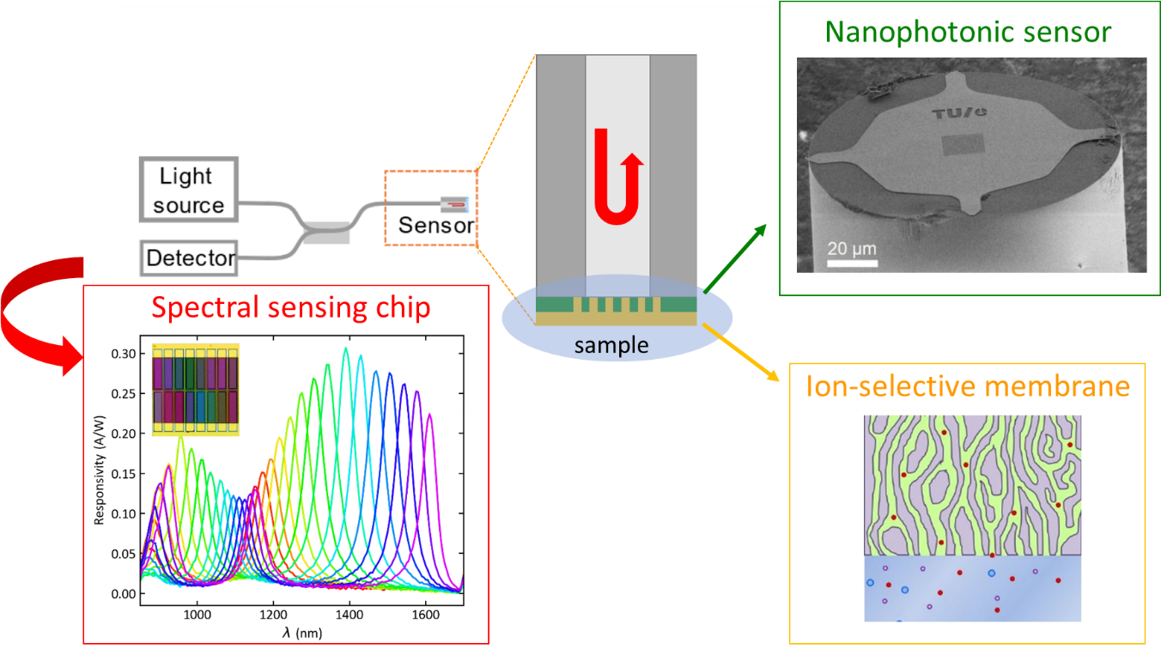

Photonic crystals are nanophotonic structures based on a periodic modulation of the refractive index. They allow defining sharp spectral resonances whose wavelength depends on the environment (temperature, refractive index, force, etc), which makes them exquisite optical sensors. Our group has developed a novel generation of fiber-tip photonic crystal sensors which can be read-out directly via the fiber, using an integrated spectral chip. In this project, you will explore a novel application field for these sensors, namely the measurement of nitrogen compounds (ammonia, nitrate) in water. These compounds constitute a main source of pollution - low-cost, miniaturized water quality sensors are needed to monitor nitrogen emission. To enable specific detection of the target analyte you will optimize the deposition of ion-selective membranes onto photonic crystals, characterize their sensitivity to ammonia and nitrate, and the specificity against other environmental changes.

**Fiber-tip accelerometers (MSc project)**

Supervisors: Arthur Hendriks/Mildred Cano/Anne van Klinken/**Andrea Fiore (a.fiore@tue.nl)**

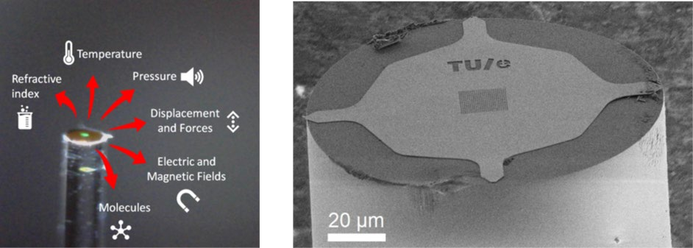

The energy transition implies the widespread electrification of energy production systems. Traditional electrical sensors are often not suited for the monitoring electrical energy systems due to their sensitivity to strong electric fields. The measurement of acceleration and vibrations is a key requirement, for example in wind turbines, as it provides information on aging and reliability. Fiber-optic accelerometers would be ideally suited for this application, but present solutions are much too complex and expensive. In this project you will explore a novel approach to the measurement of acceleration, based on a nanophotonic fiber-tip sensor and read-out technology developed in PSN. You will optimize the mechanical and optical response of different sensor designs, fabricate the sensors and test their response to acceleration. The expected outcome is a fiber-optic accelerometer featuring performance and footprint suitable for application in wind turbines.

**Investigating strong light-matter interaction in 2D Materials using terahertz microscopy (MSc project)**

Supervisors: Djero Peeters/ **Jaime Gómez Rivas (j.gomez.rivas@tue.nl)**

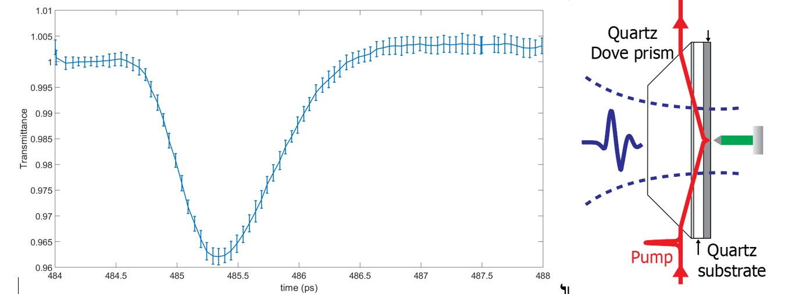

Atomically thin semiconductors have created a lot of interest in the scientific community. They can have very high charge mobilities, optical absorption and transition from indirect band-gap semiconductor in bulk to direct semiconductor at a monolayer thickness. We have recently developed a unique near-field microscope that can generate and detect radiation in the deep infrared region of the electromagnetic spectrum, i.e., the terahertz (THz) frequency range. This microscope detects the time dependent free carrier absorption of materials after photo-excitation with ultrashort optical pulses and with subwavelength spatial resolution, which allows to determine the carrier mobility and free carrier density. In this project, you will investigate the properties of chemically grown and exfoliated 2D semiconductors using THz near-field microscopy and, more specifically, how these properties can be modified and enhanced using resonant (nanophotonic) structures, which interact with the semiconductor. The impact of this research is on improving the performance of organic opto-electronic devices using novel nanophotonic concepts and to use THz microscopy to characterize this improvement. Skills that you will acquire are working with (ultra-fast) laser systems and THz systems, and performing high precision optical measurements.

**Design of plasmonic dimers particle arrays for vibrational ultrastrong coupling (BSc/MSc project)**

Supervisor: Francesco Verdelli/ **Jaime Gomez Rivas (**j.gomez.rivas@tue.nl**)**

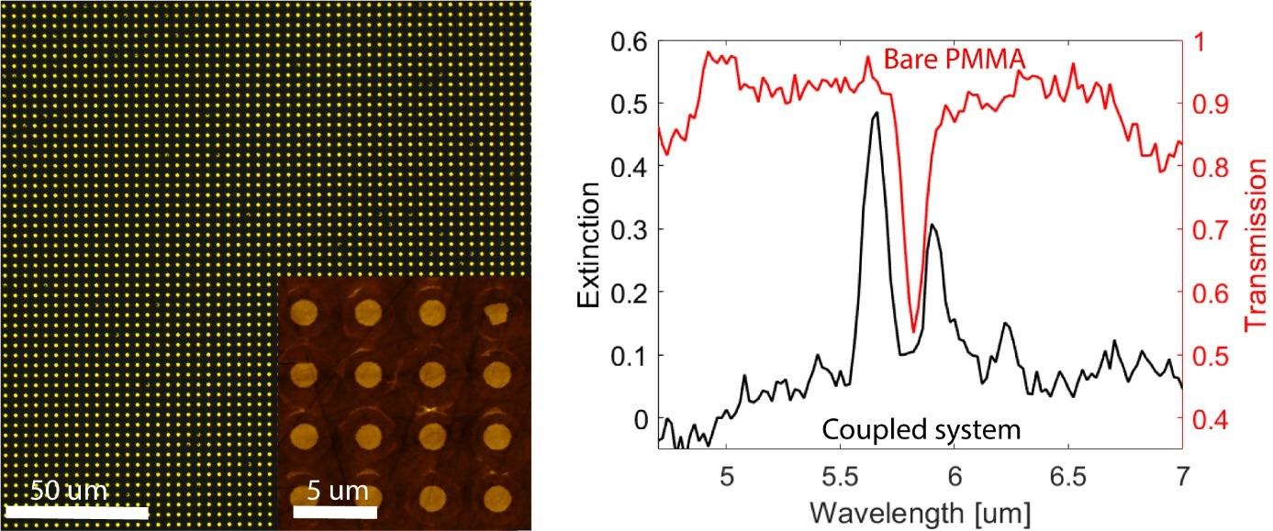

The ultrastrong coupling (USC) regime is established when the energy of the interaction between light and matter is a comparable fraction of the bare energies of the coupled elements (e.g. molecular vibrations and photons). This interaction is governed by the coupling strength between the elements of the system. USC coupling is interesting because it can modify reaction rates of molecules that are strongly coupled to the vacuum field of an optical cavity and enhance the cross section of Raman scattering, which can open new avenues in chemistry and spectroscopy. The coupling strength can be tuned in the infrared using microstructures capable of sustaining huge field enhancements, such as dimers or nanogap antennas. In this project, you will simulate and experimentally investigate possible cavity designs to achieve USC between a molecular vibration resonance and cavity modes in arrays of dimers. The aim is to create a new open platform capable of achieving USC for future studies of polaritonic chemistry. The skills that you will acquire range from designing the microstructures using simulation software to working in a clean room and an optical lab.

**Exploring Valley Polarized Exciton-Polaritons in 2D Superlattices (MSc Project)**

Supervisors: Simrjit Singh/Sara Elrafey/**Jaime Gomez Rivas**

(j.gomez.rivas@tue.nl)

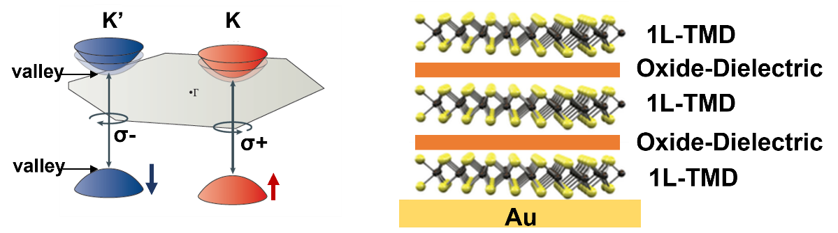

Atomically thin 2D semiconductors possess a variety of intriguing properties thereby, offering unique opportunities for quantum information processing applications. The inversion symmetry breaking and spin-orbit coupling leads to a strong spin-valley locking effect at two distinct K and K’ valleys in the electronic band structure that can be selectively addressed using circularly polarized light. A carrier population imbalance created in these two valleys, termed as valley polarization, can be used to store the binary information. Furthermore, the formation of hybrid quasiparticles i.e. exciton-polaritons, can be realized in these semiconductors when the valley addressable excitons are strongly coupled to the optical resonances. In this project, we would explore the formation of exciton-polaritons and their valley selectivity in artificially designed 2D superlattices consisting of an alternate stack of monolayer 2D semiconductors and thin dielectric spacers. The 2D superlattices are recently explored structures for light manipulation in future high-performance optoelectronic and photonic components however, the emergence of excitonpolaritons and their valley selectivity is largely unexplored in these structure. This project would include the fabrication of superlattice structures, the measurement of the reflectance, photoluminescence, circularly polarized photoluminescence and lifetime measurements at room as well as cryogenic temperatures. A part of your efforts will also be focused on numerical simulations.

**2D/3D Tandem Devices for Solar Hydrogen Generation (MSc Project)**

Supervisors: Simrjit Singh/**Jaime Gomez Rivas** (j.gomez.rivas@tue.nl)

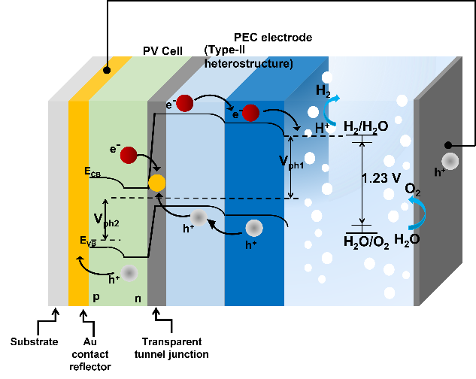

Efficient self-powered solar hydrogen generation, a pathway to store solar energy in the form of chemical bonds, using tandem photoelectrochemical/photovoltaic (PEC/PV) devices, requires the optimization of front PEC electrode which is limited by the low photocurrent generation. The present project is targeted on the fabrication of PEC/PV tandem devices utilizing ultrathin 2D materials and 3D semiconductors with appropriate bandgaps as PEC electrodes and PV cells. Photocurrent in the PEC electrode will be maximized through optical engineering such as by using hybrid conductive distributed Bragg reflector geometry and/or 3D ordered macro-mesoporous scaffold for enhancing light trapping and absorption in the PEC electrode. This project will include the fabrication/assembly of tandem device structures, photoelectrochemical measurements such as I-V, Impedance spectroscopy and Mott-Schottky etc., and a part of your efforts will also be focused on numerical simulations for the optimization of the device structure.

**Separation and propagation of WSe2 valley polarized emission in integrated photonic circuits (MSc project)**

Supervisors: Minpeng Liang/**Jaime Gómez Rivas** (j.gomez.rivas@tue.nl)

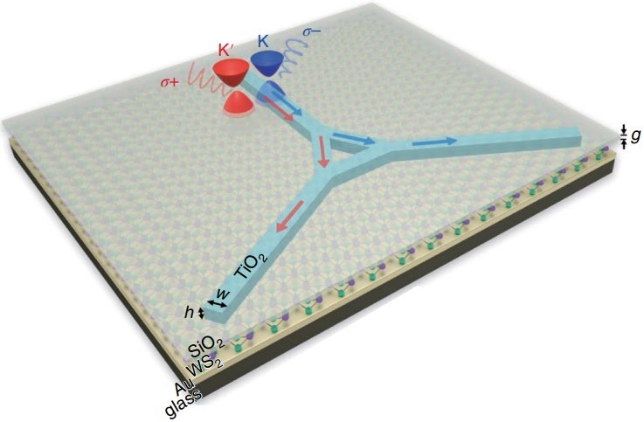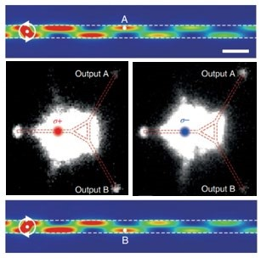

Chen, Yang, et al. "Chirality-dependent unidirectional routing of WS2 valley photons in a nanocircuit." *Nature Nanotechnology* 17.11 (2022): 1178-1182.

Valley-dependent excitation and emission in transition metal dichalcogenides (TMDCs) such as WSe2 and WS2, have emerged as a new avenue for optical data manipulation, quantum optical technologies, and chiral photonics. The valleypolarized electronic states can be optically addressed through photonic spin-orbit interaction of excitonic emission. However, transferring the valley information with high fidelity, high efficiency and over long distance is still challenging. Here we propose a project which will work on this direction.

The project includes the design and optimization of waveguide structures (simulation), the nanofabrication and the optical characterizations of the devices. The goal of this project is to achieve a waveguiding device which can separate and propagate the chiral signal with high efficiency as it is needed for potential applications in quantum communication.

**Atomic scale observation of dopants in semiconductors (MSc project)**

Supervisors: Tom Verstijnen/**Paul Koenraad (p.m.koenraad@tue.nl)**

Does observing and manipulating solid state materials on the scale of single atoms sound interesting to you? Semiconductor materials are essential for our society, since they power LED’s, computer chips, solar panels and much more. A very important method to control the properties of semiconductors is through doping. Doping introduces new atoms in the material, which can supply extra charge carriers and even change the bandgap of the host material. A good understanding of doping is required to semiconductor devices even further. We use scanning tunneling microscopy (STM) to study these materials at the atomic scale. With this we can look at the effects and properties of single doping atoms. This allows us to see the displacement of single atoms and even to observe their electron wavefunctions. Our main interest is in isoelectronic impurities, these do not introduce extra carriers but change the properties of the host materials through strain and other effects. Examples of iso-electronic doping are Nitrogen (N) and Bismuth (Bi) in Gallium Arsenide (GaAs). Below you can see a typical image that we can make with the STM, where we can see single Bi (bright dots) and N atoms (dark rectangles) in GaAs. Possible projects could be studying the spatial distribution of these isoelectronic dopants or looking at their local electronic interaction with the host.

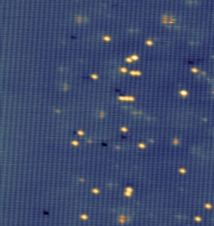

*Figure 1 20x20 nm2 STM image of GaAs containing both Bi (bright dots) and N atoms (dark rectangles)*

**Atomic-scale characterization of antimony based III-V semiconductor devices and materials (MSc project)**

Supervisors: Aurelia Trevisan/**Paul Koenraad (p.m.koenraad@tue.nl)**

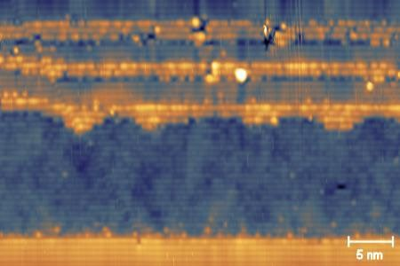

*STM image of an ULTRARAM device*

Antimony based III-V semiconductors have a wide range of applications in Electronics, Optoelectronics and Quantum information technologies. We offer the opportunity to observe these materials at the atomic scale using cross sectional scanning tunnelling microscopy (X-STM). Here we study what these materials actually look like at this scale and how devices that are grown are actually formed. You can study many characteristics of these materials. For instance interface qualities, defect distribution and individual dopant behaviour. If you have ever wondered what the devices that lie at the basis of cutting edge technology look like at the smallest scale this is the way to find out. Some examples of materials and devices we study are Sb distribution and wave function in GaAs and the study of ULTRARAM devices, alongside many more Sb based materials. An example of the ULTRARAM device is shown in the figure where you can see how clearly we can identify layers of different materials and interface quality and the rich world of these semiconductors at the atomic scale.

**Studying individual dopants in III-V semiconductors using cutting edge simulation techniques (BSc, MSc project)**

Supervisors: Tom Verstijnen/ Julian Zanon /**Paul Koenraad**

# (p.m.koenraad@tue.nl)

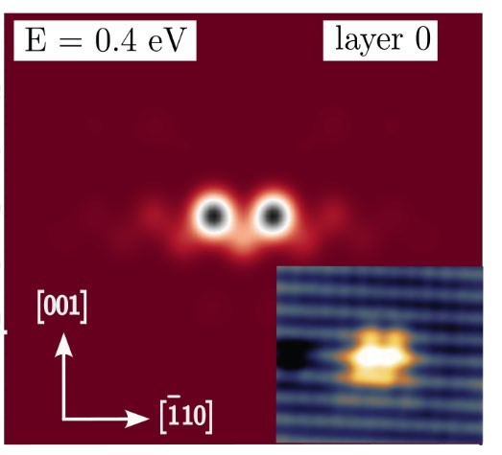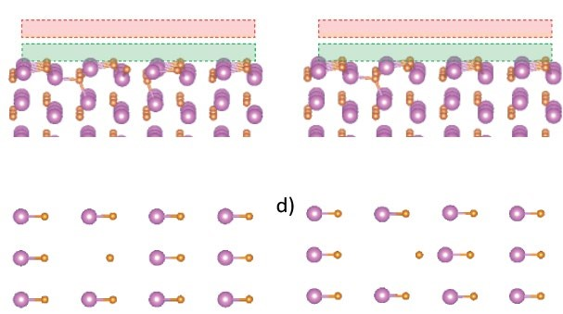

***DFT Simulations of the relaxation of the Ga vacancy in***

***GaN*  *Tight-Binding simulations of the B wave function in GaAs***

Semiconductor materials are the foundation on which many technologies are built nowadays. The size of our devices has been decreasing rapidly over the last decades. This has been made possible by the fact that we can now control these materials at the atomic scale. We use cutting edge simulations methods to characterize how individual dopants behave in III-V semiconductors. We work closely with experimental results from our group to directly compare these simulations to experimental results. Dopant characteristics we study include dopant distribution, wave function shape, energy levels of dopant states and material relaxation around dopants. The simulation techniques we have available include Density Functional Theory (DFT), Tight-Binding simulations (TB) and the QuTip package of python. Some examples of systems we study are the wave function and energetic state of Boron in GaAs, the bi stability of the Ga vacancy in GaN and nitrogen-hydrogen complexes in GaAs.

**Optomechanical control of photon polarization (MSc project at AMOLF, Amsterdam)**

Supervisor: **Ewold Verhagen (**[**verhagen@amolf.nl**](mailto:verhagen@amolf.nl)**)**

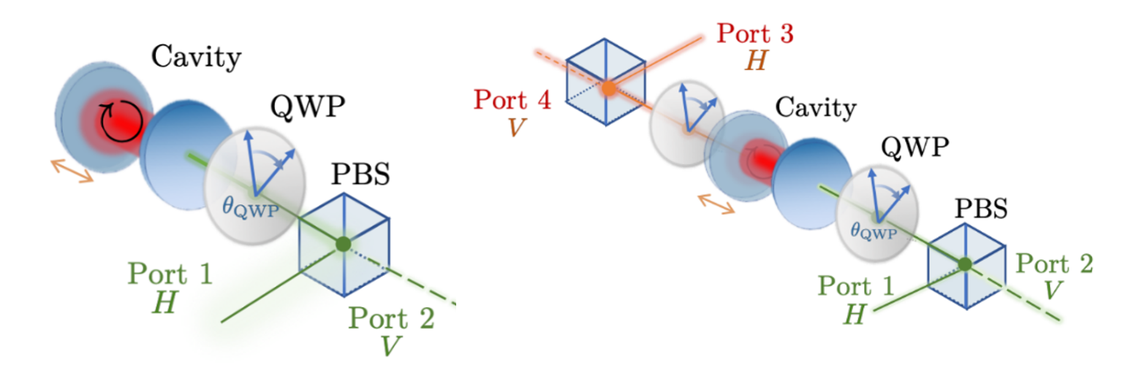

A powerful optomechanical system consists of a piece of crystal placed between two mirrors. Ultrahigh-frequency sound waves in the crystal then couple strongly to the photons in the cavity. We have predicted that an intriguing effect could happen in these cavities: A photon passing through the cavity can change its polarization under the influence of a second laser beam, through a nonlinear interaction mediated by acoustic phonons in the crystal. This is thus analogous to the Faraday effect in magneto-optic materials - but without any magnetic field. You will develop a new setup to observe optomechanical interactions in such crystals, with the aim of observing the optomechanical Faraday effect. This project is carried out in the *Photonic Forces* group at the AMOLF institute in Amsterdam.

**Computation with nano-optomechanical resonators (MSc project at AMOLF, Amsterdam)**

Supervisors: Marc Serra Garcia / **Ewold Verhagen (verhagen@amolf.nl)**

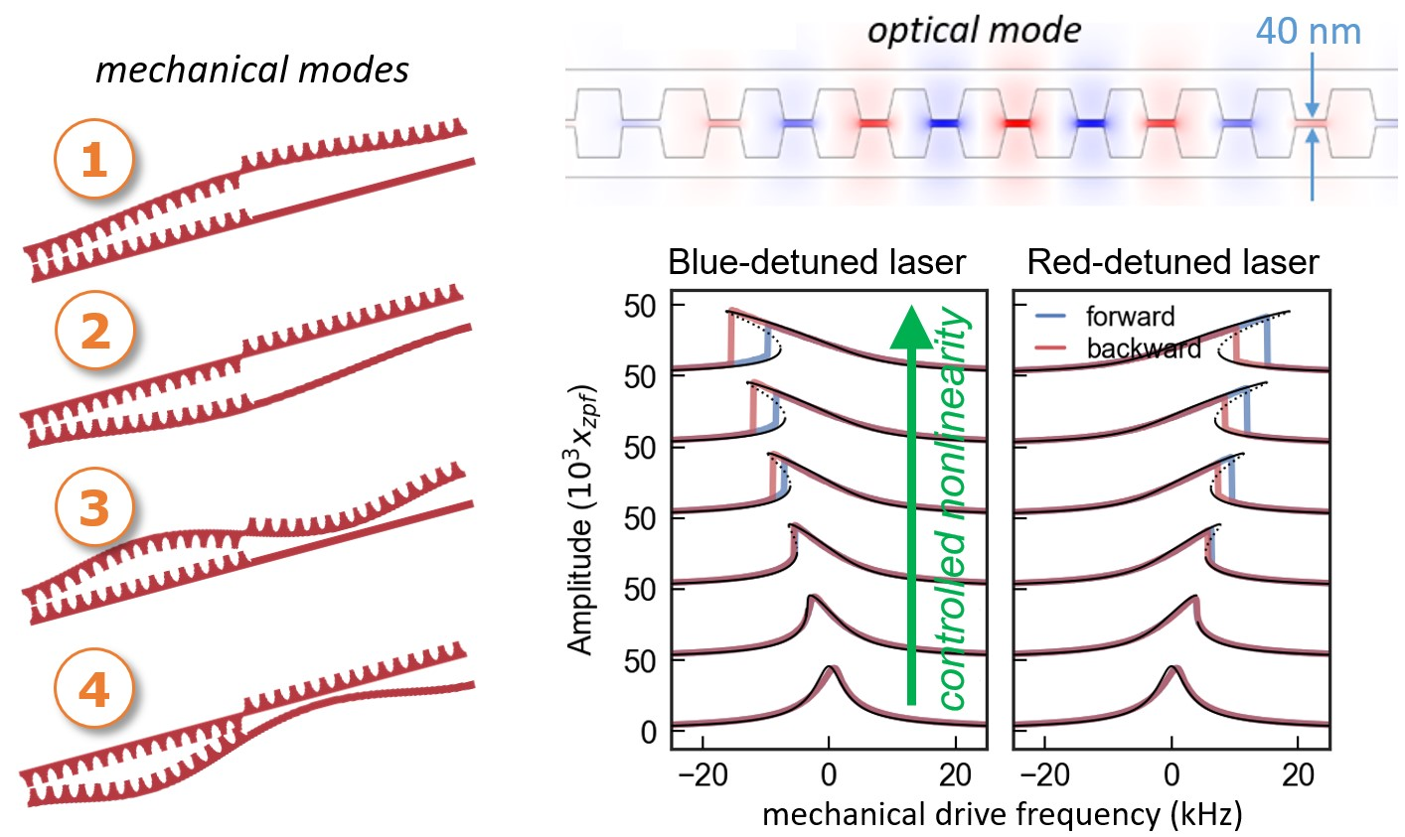

There is a high interest in investigating alternative paradigms for computing, for specific applications related to analog simulation and artificial intelligence, and to study fundamental thermodynamic principles that govern the performance of information processing systems. Under the right conditions, computational tasks can be encoded in the response of nonlinear resonators. We have recently discovered that very strong nonlinearities can be induced in nanomechanical resonators through their radiation pressure interaction with laser light. In this project, we will explore if we can configure different types of logic gates in the nanomechanical domain through by choosing smart temporal modulations of laser light that controls the system response. Through sensitive optomechanical readout of the motion, we aim to test computation performance at the thermal noise limit. You will fabricate these optomechanical devices and demonstrate in proof-of-principle experiments that they can be used as small computing elements. This project is carried out in the *Photonic Forces* group at the AMOLF institute in Amsterdam.

**Controlling the quantum state of an ultracoherent nanostring with light (MSc project at AMOLF, Amsterdam)**

Supervisors: Menno Jansen/**Ewold Verhagen (verhagen@amolf.nl)**

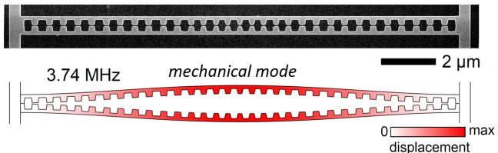

Even macroscopic objects can exhibit the strange behavior associated with the laws of quantum mechanics. In this project, you will cool a nanostring vibrating at MHz frequencies close to its quantum ground state of motion, using the forces exerted by laser light combined with very sensitive measurement. To do so, you will develop new on-chip nanomechanical resonators made from silicon nitride, in which mechanical decoherence can be extremely small. In a cryogenic setup, we will then seek to test a new theoretical prediction that a short, intense laser pulse could induce a special ‘squeezed’ quantum state in the mechanical string. You will design the systems, fabricate them in the cleanroom at AMOLF, and characterize their performance in high-precision optical measurement. This project is carried out in the *Photonic Forces* group at the AMOLF institute in Amsterdam.



Supervisors:

**T.b.d. (TU/e)**

**Dr. Irwan Setija (ASML - TU/e)**

Photonics and Semiconductor Nanophysics group of the Applied Physics faculty (TU Eindhoven)

t.b.d.

[irwan.setija@asml.com](mailto:irwan.setija@asml.com)

Designing Fano resonances in photonic nanostructures through Global Optimization

MSc project (Photonics and Semiconductor Nanophysics)

Background

ASML is the largest manufacturer of lithography equipment in the world. With its continuous drive to image smaller integrated circuit structures, ASML provides the enabling technology for the semiconductor industry to develop ever more powerful computer chips.

A very important aspect of semiconductor manufacturing is metrology, i.e. the measurement and qualification of shape and position of the imaged nanopatterns. At ASML there is a very strong drive to use optical methods to do metrology because of the non-invasive character and high dynamic range. Even nanostructures smaller than the optical resolution-limit, can still be qualified using scatterometric methods. In the past, ASML has had a strong collaboration with the TU/e Mathematics and Electrical Engineering faculties to develop efficient numerical algorithms to solve Maxwell’s equations and to solve the inverse problem where the shape of a subwavelength structure is reconstructed from the scattering spectrum.

Project description

In this internship, we want to explore a novel scatterometry principle where we use metrology targets with a photonic Fano resonance. Fano resonances lead to a strong field concentration in nanostructures and are known to have a strong response to shape deviations. This measurement principle is the topic of a larger research project between the TU/e and the AMOLF in Amsterdam. The design of Fano resonances in photonic nanostructures is very difficult. In this internship we will study the behaviour of Fano resonances in known structures as a function of shape deviations and we will study the performance of various global optimization algorithms to find this Fano resonance. You will make use of an efficient numerical algorithm to solve Maxwell’s equations developed by ASML in collaboration with the TU/e. This algorithm will also be the forward engine in various global optimization algorithms like Bayesian optimization, particle swarm and genetic algorithms.

Project organization

You are an excellent and motivated master student in applied physics with a thorough education in Electromagnetism, Nanophotonics and Computational Physics. You are a problem solver who is challenged by fundamental physics and looking for applications in measuring subwavelength structures. In this 9-month internship you will be based at ASML for at least 2 days per week under the supervision of an ASML research scientist.

**Imaging of nanoimprinted optical waveguides (Masters project at Morphotonics, minimum 6 months)**

**Supervisors /contact :** Mariana Ballotti **mariana.ballottin@morphotonics.com**

Jan Matthijs ter Meulen **jan.matthijs.ter.meulen@morphotonics.com**

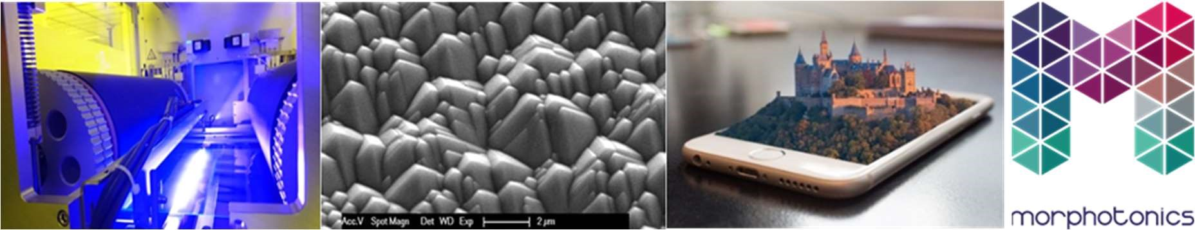

Nanoimprinting is a key technology for the manufacturing of Augmented Reality (AR) waveguides; it allows the replication of complex structures with precision. Morphotonics has demonstrated that it is possible to scale up from wafer level, and to cost-effectively produce 270 waveguides per machine cycle (Gen5 size – 1100 x 1300 mm2). However, while scaling up, it is important to maintain the quality. In order to assess the replication quality of these optical elements, Morphotonics has built an imaging functional tester, which allows image quality measurements of diffractive waveguides. This is a complex challenge, which typically concerns the following questions & activities:

* What are the differences in image acquisition for different imprinted diffractive waveguides (e.g. slanted, blazed and binary gratings)?
* Verify current imprinted waveguide replication quality.
* Testing & improving setup (e.g. different lens or light source, ways of improving alignment and reproducibility).
* Use the available method, and propose new methods of data analysis for the obtained images.

This means studying the literature in-depth, proposing optical solutions, performing sample characterization and data analysis. Working for a scale-up company means that the internship is diverse. The work requires innovative ideas, dedicated tests and teamwork with a team of engineers and specialists. Our atmosphere is academic and we will fully support you with your work and study; we know what it takes. More information can be found at www.morphotonics.com.

If you want to meet this challenge and think you fit, please drop us an email and brief resume. We look forward to it!

We are eagerly looking for students to support us in further developing our cutting edge technology. We have an opening for a masters assignment (minimal duration 6 months) with the following profile:

* Student of (Applied) Physics;
* Experienced with setting up and carrying out a development plan;
* Hands-on attitude;
* Positive and enthusiastic personality, able to work alone and in a team; - Good communication skills, stress resistant and a good sense of humour; - Location: Veldhoven/Eindhoven.

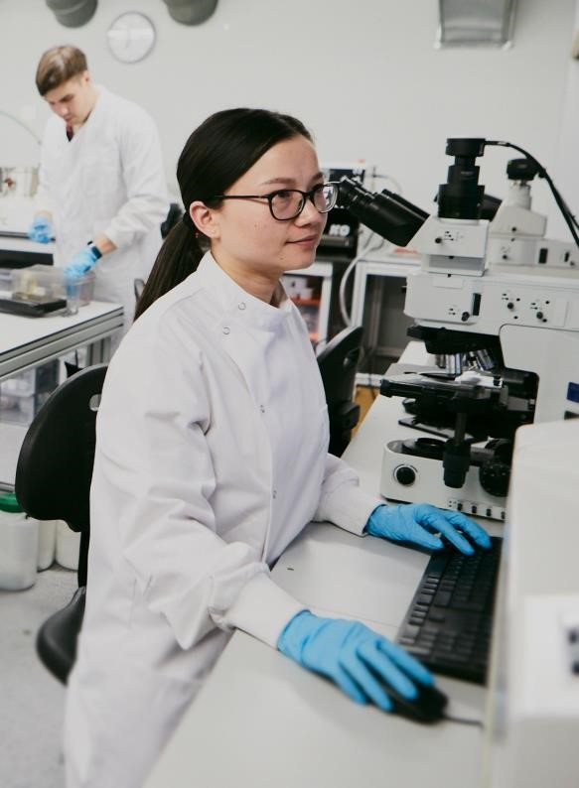

T

rustees



CE

RC

A Cent

r

e

Member of



Supported

by



Distinctions



•

M

edical

Optics

•

Biophysics,

Biophotonics

& Super

-

Resolution Imaging

•

Photovoltaics, Thermal Photonics & Solar Fuels

•

Quantum and Low

-

Dimensional Materials

•

Optical Sensing & Optoelectronics

•

Ultracold

Quantum Gases

•

Nonlinear

Optics

,

Ultrafast

Optics

& Atto

-

Science

•

NanoPhotonics

&

NanoMechanics

•

Quantum Communications, Sensing & Simulation

•

Quantum Optics & Quantum Information

•

Nanophotonics

, Condensed Matter physics and Light

Matter Interactions

**Internships**

**for**

**Undergraduate**

**&**

**Masters**

**Students**

ICFO

offers

the

opportunity

to

undertake

a

**Final**

**Degree**

**Project,**

a

**Masters**

**Thesis**

or

to

participate

in

a

Research

Stay

with one of our

Research

Groups.

In

this

call

we

offer

the

following

fellowships,

which

cover

funding

for

up

to

12

-

months.

For

further

information

about

the

research

groups

and

activities

at

ICFO,

please

visit

[/](https://www.icfo.eu/lang/research)

[http://www.icfo.eu](https://www.icfo.eu/lang/research)

F

o

r

additiona

l

questions

,

pleas

e

contac

t

u

s

a

t

jobs@ic

fo.

eu

.

Program

details

and

applications

are

available

at

[u](https://jobs.icfo.eu/?detail=747)

[http://jobs.icfo.e](https://jobs.icfo.eu/?detail=747)

Deadline

for

applications

:

March 30,

2023



Funded

by

Projects

may

be

undertaken

with

any

Research

Group.

Research

lines

include,

but

are

not

limited

to,

theoretical

and

experimental

aspects

of:

**6**

**x**

**Student**

**Research**

**Fellowships**

