Date: August 1, 2020
EB number …………

In view of legislative changes aimed at prohibiting smoking on campuses and more particularly in view of Section 10(1) of the Tobacco and Related Products Act, the Executive Board of the Eindhoven University of Technology
DECIDES
I. To revoke the TU/e non-smoking regulation 2007.
II. To adopt the Smoke-free Campus regulation 2020 below regarding a total smoking ban for TU/e with effect from August 1, 2020.
Smoking ban
1. The smoking ban applies to all forms of smoking, including e-cigarettes and all other forms of smoking material. The smoking ban is effective throughout the demarcated indoor and outdoor smoke-free area on the TU/e campus including the ancillary buildings, as indicated in the Annex: Map of the smoke­free area.
Implementation
2. The managers of the buildings are charged with the implementation of this regulation in the building.
3. TU/e is charged with supervising this regulation on its sites.
4. The smoking ban is effective throughout the grounds as indicated on the map. The Executive Board is at liberty to modify this smoke-free area at any time.
5. All people present on the TU/e campus must adhere to this regulation.
6. Organizers of events carry full responsibility for arranging monitoring and enforcement of the smoking ban as set out in item 1 of this regulation, and shall indemnify TU/e in respect thereof.
Fine
7. The Netherlands Food and Consumer Product Safety Authority (NVWA) is authorized to enforce the regulation through the issue of fines (currently to a maximum amount of 4,500 euros) for each violation.
8. In the event that fines are imposed by the competent bodies, TU/e will be entitled to recover all costs from the specific offender, in whole or in part.

Final provisions
In all cases not provided for by this regulation, or where there is a conflict of interpretation of one or more provisions of this regulation, the Executive Board decides.
This regulation comes into force on August 1, 2020, and may be referred to as “Smoke-free Campus 2020”.
Adopted at the meeting of the Executive Board held on July 9, 2020.

Notes to the TU/e non-smoking regulation
General:
Resolution of June 22, 2020, regarding amendment of the Tobacco and Related Products Act introducing the duty to institute, indicate and enforce a smoking ban on sites belonging with buildings and institutions used for education.
The TU/e Smoke-free Campus 2020 regulation was adopted on the basis of this. The manager of a building and Internal Affairs are charged with the implementation and enforcement of this regulation.
The regulation applies to all people present at TU/e within the demarcated smoke-free area (see the map of the smoke-free area).
The regulation applies to all tobacco products, e-cigarettes and any other form of smoking products.

More specific notes:
In view of the nature and objective of the regulation, an established violation of the regulation may be reported to the manager of the indoor or outdoor area in which the violation took place.
Before reporting the violation, the manager in question must point out the smoking ban to the offender and ask them to stop smoking immediately.
The manager in question reports the violation to any person closest to the offender.
For a first violation of the smoking ban, the offender will receive an oral warning from their direct supervisor.
Moreover, TU/e reserves all rights and, additionally, always has the right to recover any fines that have been imposed from every offender, in whole or in part.
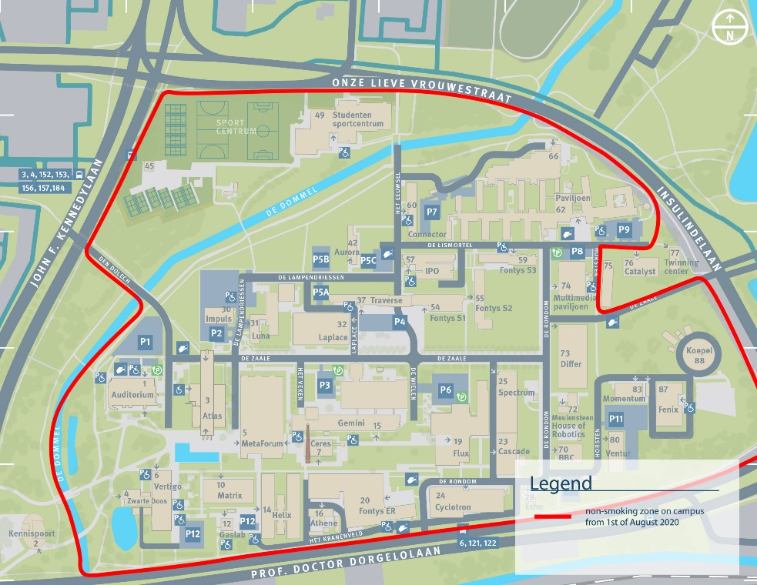
Map of smoke-free area

