Needed info for your Community Page
For your own page at the TU/e website, we have a form in two parts:
1. Basic content website, mandatory to have your own page on the TU/e website
2. Options for personalization, only if you would like to add more details on your page
The new TU/e website will be built completely in English.

Basic info: please fill in the form below and send it to: lisservices@tue.nl
Please add photos separately.

Name community
Type of association  (select the right ones, multiple options) | Please select the right ones and delete the others:  (i.e. study, cultural, sports, employers, other etc.)
Target group  (select the right ones, multiple options) | Please select the right ones and delete the others:  Bachelor Students  Master Students  PhD/PDEng  Employees  Alumni  Other
Background colour  (select the color of your preference) | Please select your 1st and 2nd preference color and delete the other ones:  Blue  Purple  Pink  Orange  Green  Turquoise
Short description (text) of association
(max. 144 characters, including spaces)
Long description (text) of association
(any length)
Picture or video for header  (picture minimum 2880 pixels wide and resolution of 72 dpi, png/jpg) | Representative picture (in jpeg) for your community/association or video link (also add picture if you have a video link). Please attach these pictures separately.
Logo  (minimum 500 pixels wide and a resolution of 72 dpi, png/jpg) | A transparent logo (in jpeg) is the best option (if available).
Link to own website
(if available)
Contact block
- Contactperson or comittee
  - Name
  - Phone number: +31(0)
  - E-mail:
- Postal address
  - P.O. Box
  - City
- Visiting address
  - Building
  - Building number (check your building number at the map in the link)
  - Streetname
  - Postal code
  - City
Social Media (if applicable, provide link)
- Facebook
- LinkedIn
- Twitter
- Instagram
- Youtube
- Other…

Options for personalization
We offer several options for personalization of your community page. Please indicate your interest and provide content if this is available. We cannot guarantee that this will be placed before release 1: April 1st 2018, but will place it as soon as possible.

Projects  (text & photo per project)  (pictures minimal 2880 pixels wide and resolution of 72 dpi) | Text per project max 100 characters include spaces
Highlighted Project  (text & photo for project)  (pictures minimal 2880 pixels wide and resolution of 72 dpi) | Text per project max 800 characters include spaces
Groups & Subgroups  (text & photo per group)  (pictures minimal 2880 pixels wide and resolution of 72 dpi) | Text per (sub(group) max 100 characters include spaces
Highlighted Groups  (text & photo for group)  (pictures minimal 2880 pixels wide and resolution of 72 dpi) | Text per project max 800 characters include spaces
Still under development: Person Slider  (are you interested?) | Yes/No
Still under development: Photo Slider (are you interested?) | Yes/No

More information and contact

http://www.tue.nl/community

lisservices@tue.nl

Preview:
Basic page
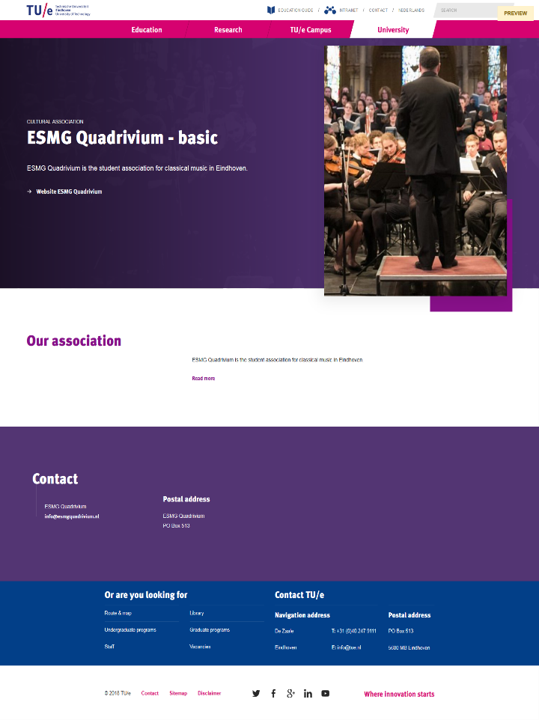

Personalized page
