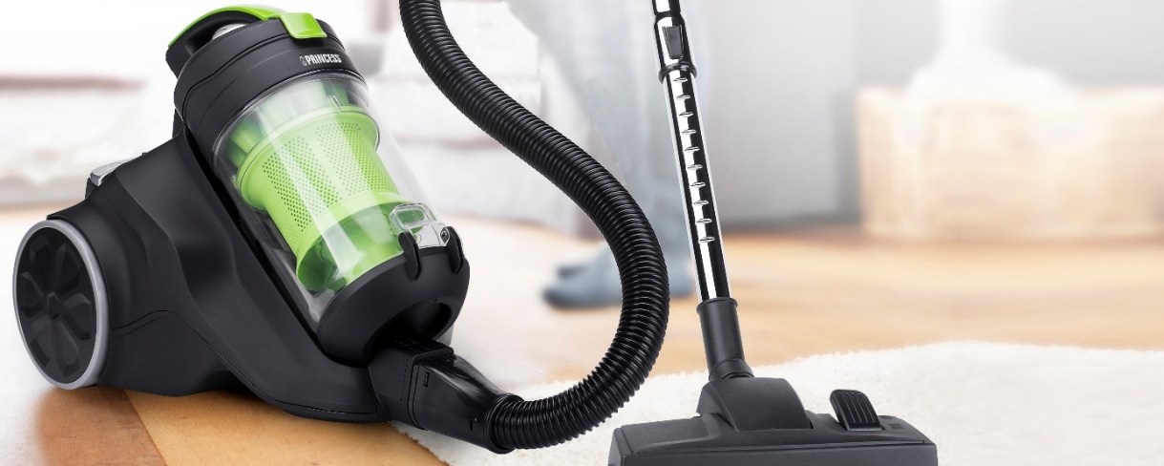

INTERNSHIP INDUSTRIAL DESIGN
Are you passionate about designing consumer electronics, and would you like to do your internship at an international company? Smartwares Group is looking for a pro-active Industrial Design Intern starting from September 2024.
Starting this September, we are seeking a proactive Industrial Design Intern who, together with the rest of our team, will translate current trends into new and better products! Smartwares Group has an extensive portfolio of more than 1500 different products that we offer to both retailers and e-tailers domestically and internationally. Are you our future intern who will help us expand and enhance our assortment? Apply now!
Who are you?
- You are pursuing a HBO or WO Education in the field of Industrial (Product) Design or something similar;
- You are passionate about consumer electronics and eager to learn in a commercial environment;
- You're well-equipped with creativity, design skills and knowledge of Solidworks;
- You're eager to join the team for a hands-on internship, working 32 - 40 hours per week.
What are you going to do?
- Conduct research on current market trends, consumer preferences, and industry innovations to gain insights and identify opportunities for product improvement and innovation;
- Translate these market research findings into ideas and design concepts;
- Developing detailed SolidWorks designs and creating new ideas and sketches while keeping design guidelines and technical specifications in mind;
- Gaining hands-on experience in working with Chinese suppliers and other stakeholders while following defined milestones of the product development process.
Who are we?
Making your home more comfortable, safer and smarter is our mission! As an international supplier of smart home products, Smartwares Group offers a wide range of products ranging from kitchen appliances and security cameras to smart lighting and smoke detectors. Along with more than 160 colleagues in the Netherlands, Europe and Asia, we work hard each and every day to make people’s daily lives safer and more comfortable through affordable, well-designed and easy-to-use smart products.
What do we offer?
- A challenging internship, where you'll be seen as a valued member of the team. You'll receive responsibility, sufficient guidance, and a compensation of €300 per month (based on a 40-hour workweek).
- A warm welcome from over 160 enthusiastic colleagues at our headquarters in Tilburg.
- A relaxed and informal working environment within an international company.
- Staff discounts on all products in our assortment. Please be aware, your whole house will soon be filled with our brands!
- Your day starts flexible; you can start between 07:30 and 09:00.
- Room for growth in terms of content and responsibility.
- Parties, drinks, team outings, and an active staff association that organizes various activities monthly.
- A canteen with Mario Kart on the Switch, Ping-pong and table football, and daily fresh fruit!
Meet your future!
Curious about who we are and what we do? Please visit our website and view our story and the one of your future colleagues on www.werkenbijsmartwaresgroup.com!
Interested?
Please visit our career website www.werkenbijsmartwaresgroup.com. You can always contact us via email or call us for more information!
Contact person:
Yochem Aerts | HR Intern
recruitment@smartwaresgroup.com
Tel: 088 – 59 40 421

