PT-ICT information

Marlies van der Weerden, Rianne Conijn, Sandra Rozemeijer
Version August 2022

All PT-graduates have direct access to the master HTI, regardless of the courses in the elective space. PT-ICT students who may be interested to continue their studies in the direction of Data Science, Artificial Intelligence or Computer Science can have direct access if they choose suitable electives. Of course, those electives are highly relevant for the continuation in HTI as well.

This document provides an overview of the relevant courses and elective packages for PT-ICT students. The first section focuses on the ICT core courses, the second section on relevant master programs, and the last section on elective packages and courses offered by Data Science and Computer Science. We conclude with an overview of the list of engineering courses (Appendix).

Some remarks for all students:
  - Check the OER requirements regarding your elective space here.
  - In addition to the 20 ects obligatory courses of your track, you need to choose 15 ects additional engineering courses. Preferably this is a complete elective package as listed here because of the coherence and level of the courses.
  - Engineering courses are courses with course codes 2xxxx – 8xxxx and the Jxxxx courses as mentioned in appendix 2.
  - Overlap is not allowed; check the overlap table here.
  - As packages in the ICT domain may contain courses that are also an obligatory part of the ICT-track you may need to combine an elective package with another related course. This document describes some options to do so. You may combine up to 15 ects for one elective package and up to 25 ects for two elective packages. You always need to ask permission of the Examination Committee (EC-IS), see here.
  - If you consider proceeding to a computer science or data science related master after your bachelor, you may choose to combine the courses you need for direct access in your elective space. This is a good motivation to ask the examination committee for approval of your package. Also via this link.
  - In case you consider another master than HTI, always check the entrance requirements at the website of that master. Ask the FTC (the departmental admission committee) of the program whether you will be accepted already in an early stage. This is free, there are no obligations to start, and you know how to change your electives in case that is needed.
  - In case you consider another master than HTI, always check which courses are excepted as deficiency. Most TU/e-masters allow direct admission with up to 3 courses deficiency, and then require that you take those courses as part of the elective space of your master (so-called homologation courses).

PT-ICT Core courses

We recommend five courses in the ICT domain.
Two courses can already be taken in year 1: JBI026 Discrete Mathematics and 2DBI00 Linear Algebra. Those two courses are good courses in your first year, fit nicely in the schedule, help you to consider whether ICT is the right track for you, and contribute already to your requirement to take three engineering courses in your elective space.
The three other courses can be taken in year 2 and 3. The order is kind of dictated by the timeslot scheduling, not by the required prior knowledge. We recommend those three courses for two reasons. First, if you choose one of those, your minimum requirement for engineering courses in the elective space is met. Secondly, you have maximum flexibility in choosing your master.
If you choose all five, you meet the minimum requirement for 25 ects in max two packages. And if you choose all five, you have direct access to HTI and DSE, and conditional access to DSAI and CSE. Conditionally means here, that you need one or two more courses that you can choose to add those in your elective space as well, of take those courses in the homologation space in your master. Always ask formal approval of the admission board of the intended master well in time.

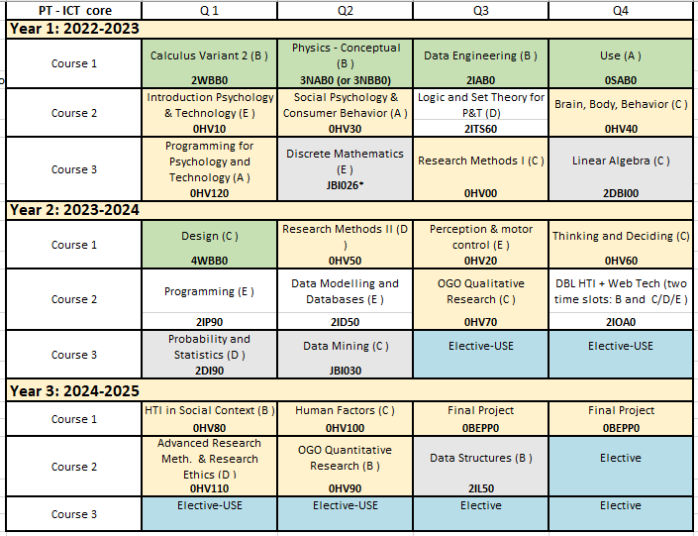
* Strongly recommended elective.

Note: The recommended course JBI026 Discrete Mathematics or the course 2IT80 are prerequisite knowledge for 2IL50.
From 2022/23 the course JBI026 has replaced the course JBI025 Foundations of Computing. JBI025 is offered for the last time in AY 2021/2022.
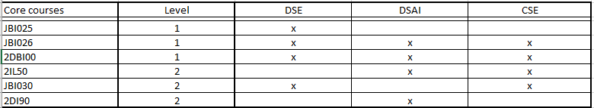

Relevant Master programs

MSc Human-Technology Interaction (HTI)
You have direct access to the HTI-master program, regardless of your choice of electives. For a good and dedicated ICT profile in the HTI-master, you of course need to prepare yourself for that in your bachelor by choosing relevant ICT electives. The core courses mentioned in this document fit well, and prepare you well for

MSc Data Science and Entrepreneurship (DS&E)
The two-year master's program Data Science and Entrepreneurship is a joint master by Tilburg University and Eindhoven University of Technology and therefore a truly interdisciplinary business-technology-analytics program. Links to the master at the JADS page and the TU/e site.

The Data Science for IE&IS elective package is developed for direct admission, see here. For PT-ICT only two courses are needed for admission because the third course – Data modeling & Databases 2ID50 is already in your mandatory ICT-track.
  - JBI026 Discrete Mathematics Q2-E (level 1). This course is required for direct admission to the JADS master program.
Note: From 2022/23 the course JBI026 replaces the course JBI025 Foundations of Computing
  - JBI030 Data Mining Q2-C (level 2). This course is required for direct admission to the JADS master program.

Those two courses can be completed to a valid technical package of 3 courses by the following courses:
  - 2DBI00 Linear Algebra Q4-C (level 1) N.B. Same slot as 0HV40. These courses can be taken simultaneously by online video college and online instructions.
  - 2ID70 Data intensive systems & applications Q3-D (level 3)
- 2DI90 Probability and Statistics Q1-D (level 2)
- (Data)Visualization Q2-D (JBI100; level 2)
- Note: PT-ICT students need two level-3 courses in their elective space. One in the USE-learning line and one other; 2ID70 could play this role.

MSc Data Science and Artificial Intelligence (DS&AI)
The Master DS&AI is intended for students interested in studying and combining advanced data analysis techniques with AI methods and techniques, in order to understand, use and develop intelligent systems to support and strengthen the human intellect. Link to the digital study guide and TU/e site.

Admission to DS&AI in general:
- Logic and Set Theory (2ITS60) and/ or Discrete Mathematics (JBI026)
- Linear Algebra (2DBI00)
- Probability and Statistics (2DI90) or Programming (JBI010)
- Data Structures (2IL50)
- Data-Modeling and Databases (2ID50)
- (Object-oriented) Programming and applying programming for problem solving (2IP90)
- (Data)Visualization (JBI100)
- Data Mining (JBI030)/Machine Learning (2IIG0)

PT-ICT students need for admission
- 2DBI00 Linear Algebra Q4-C (level 1) N.B. Same slot as 0HV40 and 0HV60. These courses can be taken simultaneously by online video college and online instructions.
- Probability and Statistics (2DI90) Q1-D (level-2)
- Data Structures (2IL50) Q3-B (level 2)
- Visualization (JBI100), Q2-D level 2
- Data Mining (JBI030) Q2-C or Machine Learning (2IIG0), Q2-C level 3
- Discrete Mathematics (JBI026), Q2-E (level 1) (for students who started 2022-2023)

Two examples how you can organize these courses in your PT-ICT program:
- You take all courses, and you can apply for direct admission to DSAI, if you want. These 5 (or 6) courses you can also use as the 15 plus 10 ects coherent packages you need in your electives.
- You take 3 out of these courses and use them as your technical package of 15 ects. You still can ask admission if you want, because you miss not more than 3 courses for direct admission. The remaining courses will become part of your DSAI program in case you want to do this master: mandatory electives, called homologation courses.

MSc Computer Science and Engineering (CSE)
The Master program in Computer Science and Engineering (CSE) gives a broad view of computer science from both a scientific and an engineering perspective and provides ample opportunities for specialization. The program offers three different streams: Software Science, Systems Science, and Web Science and the possibility to follow a program partly outside these streams, for instance to prepare for getting a teaching degree. Each stream has a core program of five courses. There is a large list of stream electives from which you should choose some courses to prepare for your master project. There is also ample room in the program to choose electives from outside your stream. Apart from the three streams there are also two special tracks: Data Science in Engineering and Information Security Technology.
Links to digital study guide and TU/e site.

Admission to CSE in general
- 2WBB0, Calculus
- 2IT60, Logic and Set Theory
- 2IP90/JBI010, Programming
- 2ID50, Data modeling and databases OR JBI050 Data management for data analytics
- 2DBI00 Linear algebra and applications OR 2WF20 Linear algebra
- 2IPC0, Programming methods
- 2IL50, Data structures (ideally should be followed by 2ILC0 Algorithms)
- 2IT90, Automata, language theory and complexity
- 2IIG0, Data mining and machine learning OR JBI030 Data Mining

PT-ICT students take:
- 2DBI00 Linear Algebra Q4-C (level 1) N.B. Same slot as 0HV40 and 0HV60. These courses can be taken simultaneously by online video college and online instructions.
- Programming methods (2IPC0) Q2-B Level 3
- Data Structures (2IL50) Q3-B (level 2)
- Automata, language theory and complexity (2IT90) Q1-B level 2
- Data Mining (JBI030) Q2-C level 2/Machine Learning (2IIG0), Q2-C level 3
While there are no strict requirements, 2IIG0 assumes that the students have followed the following courses: 2DBI00: Linear Algebra and Applications; 2IPC0 (Programming Methods); 2ILC0 (Algorithms); 2DI90 (Probability and statistics); Data analytics for Engineers (2IAB0)

Two examples how you can organize these courses in your PT-ICT program:
- You take all 5 courses, and you can apply for direct admission to DSAI, if you want. These 5 courses you can also use as the 15 plus 10 ects coherent packages you need in your electives.
- You take 3 out of these 5 courses and use them as your technical package of 15 ects. You still can ask admission if you want, because you miss not more than 3 courses for direct admission. The 2 remaining courses will become part of your master program in case you want to do this master: 2 mandatory electives, called homologation courses.

NB A related course that fits nicely in CSE but is not strictly recommended: 2IX20 Software Specification Q3-E level 3

MSc Artificial Intelligence & Engineering Systems (AI&ES)
The new master AI&ES is intended for students interested in studying, researching and combining AI methods and engineering techniques, with the aim of understanding, using and developing real-life systems for new products in a wide area of applications. This master program highly interdisciplinary. The core courses you can find here. PT students can be conditionally admitted with 0-15 ECTS of homologation. Each individual student's package will be checked to determine to what extent homologation is necessary. If your deficiencies exceed 15 ECTS, you may need to complete the pre-master program AI&ES.
Links to digital study guide and TU/e site.

Overview of relevant packages on the A-Z page

Remark in advance

You also can take standard ICT-packages, like the ones listed below and on the site Electives AZ.
These are well defined packages.
Disadvantages could be:
- These packages as such mostly do not give admission to an ICT master (if you would want this)
- These packages mostly have less courses than the lists of premaster courses described above. When you can choose 3 courses out of 5, this probably gives more flexibility in planning your bachelor than when you take 3 specified courses from a standard package.
- Some of the courses might already be present in the major, accordingly, you may need to add a relevant third course to meet the requirements of 15 ects technical courses.

Data Science for IE&IS
This coherent package provides students with the basic knowledge on data science including programming, databases and machine learning techniques. This coherent package largely covers the requirements on data science courses necessary for the direct admission of students majoring Industrial Engineering or Innovation Sciences to the master “Data Science and Entrepreneurship” in JADS, Den Bosch. JADS is the Joint Graduate School of Tilburg University and Eindhoven University of Technology (see www.jads.nl for more information).
- JBI026 Discrete mathematics Q2-E (level 1)
- JBI030 Data mining Q2-C (level 2)

Computer Science Essentials. This package provides the essentials for you to start writing your own software.
  - 2IL50 Data structures Q3-B (level 2)
  - 2ITX0 Applied Logic Q2-D (level 1)
  - In addition, students could take JBI026 (or 2IT80) before 2IL50 and/or 2IT90 after 2IL50.

Data modeling Foundations. This elective package is for students in the bachelor program Data Science and other programs (except the bachelor program Computer Science), who are interested in the master program Data Science and Artificial Intelligence (DS&AI). The courses in this package offer required and highly recommended prior knowledge for enrollment in this master program.
- Linear algebra and applications (2DBI00), Q4-C (level 1); may be replaced by JBM075 Linear Algebra for Data Science Q3(A) or 2WF20 Linear Algebra 1
- Datamining and Machine learning (2IIG0), Q2-C (level 3); 2IPC0, 2ILC0 and 2DI90 assumed prior knowledge.

Analysis of information systems for CSE, an in-depth package of three courses.
Analysis of information, data, and knowledge is increasingly important, with broad application across science, engineering, society, and industry. To tackle these challenges, knowledge and skills in the management, mining, and analysis of (big) data collections is necessary. This elective package provides deeper study of the foundations and applications of analysis of data and information systems.
  - JBI100 Visualization, Q2-D (level 2)
  - 2IX30 Responsible data science, Q3-C (level 3)
  - 2ID70 Data-intensive systems and applications, Q3-D (level 3)

‘Stand-alone’ electives
  - 2IV60 Computer Graphics remains a good free elective. Please note that linear algebra (2DBI00) is required prior knowledge.
  - 2IX20 Software Specification Q3-E level 3.
  - 2IIG0 Data Mining and Machine Learning is a free elective that can be taken, Q2-C level 3. 2IPC0 (Programming Methods); 2ILC0 (Algorithms) may be necessary/helpful.
  - 2IS50 Software Development for Engineers is not allowed in combination with 2IP90 Programming. Here you can find the complete list: overlap courses.

Appendix – J-codes

Course Code | Course Title | Q | Technical Y/N
JBC000 | Cognitive Science 1 | 3 | No
JBC090 | Cognitive Science 2 | 2 | No
JBE140 | Business Insights | 1 | No
JBE150 | Start-ups | 2 | No
JBG000 | Data Science Ethics | 4 | No
JBG010 | Perspectives on Data Science | 1 | No
JBL110 | Innovation and regulation | 4 | No
JBL120 | Law and data science | 1 | No
JBL130 | Understanding the Information Society | 2 | No
JBM040 | Business analytics | 2 | No
JBM110 | Firm's Lifecycle | 3 | No
JBM120 | Business Contracting | 4 | No
JBM130 | Entrepreneurship and Finance | 1 | No
JBM140 | Independent and corporate entrepreneurship | 2 | No
JBM160 | Data Science& Entrepreneurship in action | 4 | No
JBG030 | DBL Data Challenge | 4 | Yes
JBI025 | Foundations of computing | 2 | Yes
JBI026 | Discrete Mathematics | 1 | Yes
JBI030 | Data Mining | 3 | Yes
JBI040 | Algorithmic Aspects of Data Analysis | 4 | Yes
JBI050 | Data management for data analytics | 2 | Yes
JBI100 | Visualization | 2 | Yes
JBM010 | Data Statistics | 2 | Yes
JBM020 | Data Science research methods | 4 | Yes
JBM050 | Statistical computing | 4 | Yes
JBM200 | Generalized linear statistical models | 3 | Yes
JBM210 | Survival and Reliability Analysis | 1 | Yes
JBM220 | Multivariate Data Analysis | 4 | Yes

